**Project Goal:** Demonstrate how computer technology evolved by illustrating how computing systems work at a fundamental level with integrated circuits and microprocessors, and how those concepts are still integral for practical purposes today.

This project will consist of three parts that will all illustrate essential factors of computing.

## Part 1: Integrated Circuits

**Goal**: Show how computers work at a fundamental level by building circuits using concepts of logic gates and decoders

### Project 1: 4-bit adder using logic gates

A 4-bit adder is an important circuit in computer engineering because it forms the fundamental building block for arithmetic operations in digital systems.

Logic gates are fundamental building blocks in digital circuit design and form the basis of digital electronics. They are elementary circuits that perform logical operations on binary inputs (0s and 1s) and produce a binary output. These gates are essential in constructing more complex digital systems, such as microprocessors, memory units, and other digital devices.

In this circuit, 5 logic gate chips will be used, each gate providing two inputs and one output: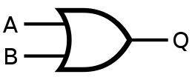

**OR Gate:** If one or more inputs are set to HIGH, the output will be set to HIGH.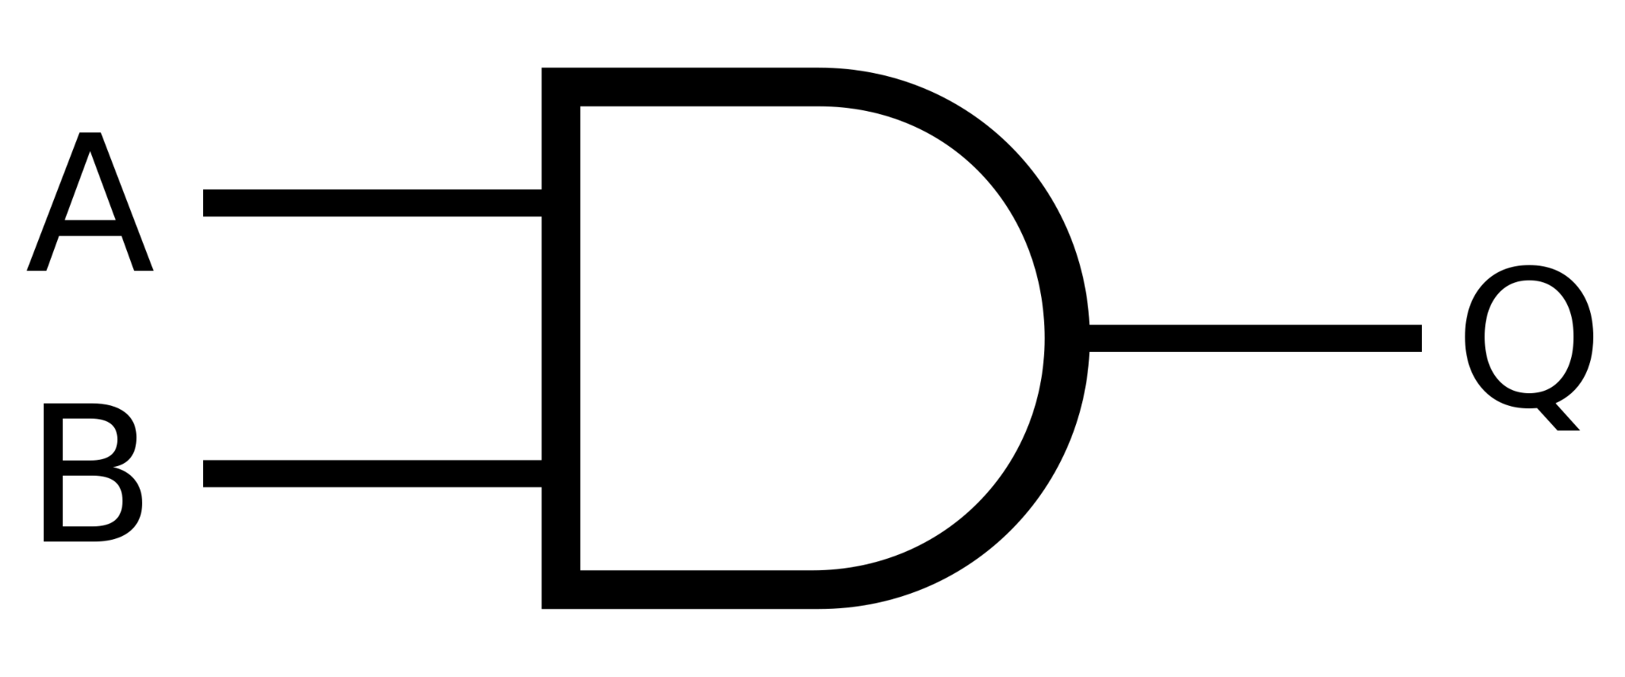

**AND Gate:** If both inputs are set to HIGH, the output will be set to HIGH.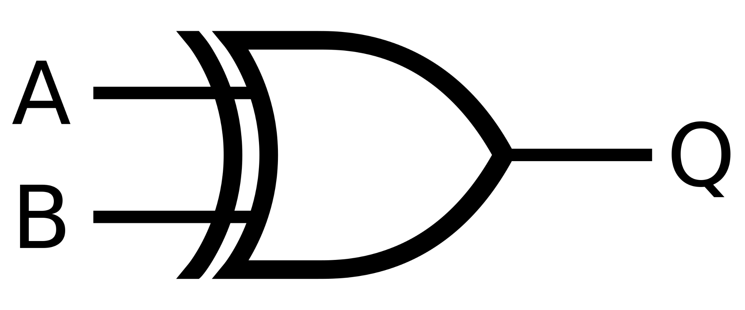

**XOR Gate:** Output will be set to HIGH if one input is set to HIGH, but not both.

By arranging these gates in a specific order, we can create a circuit that can add two sets of “4-bits” with carry.

In total, 8 XOR gates and AND gates are needed, and 4 OR gates are needed. Each chip has 4 gates, so a total of 5 chips.

The chips that I used are as follows:

**OR Gate:** SN74LS32N (x1)

**AND Gate:** SN7408N (x2)

**XOR Gate:** CD4070B (x2)

Click [here](https://drive.google.com/file/d/1dEILSuByVKMZO4pGnVvcIlrdTd_EvQve/view?usp=sharing) for a detailed view of the schematic

The 4000 series of ICs are pretty outdated nowadays, and probably shouldn’t be used in this circuit due to interference caused by the wiring, but it’s just what was on hand.

Datasheets, and more specifically, the pinouts of these chips are always useful tools to look at when designing a circuit. Understanding the pinout allows you to identify which pins are the inputs and outputs.

Reading the pinouts of these chips, we can design a circuit using the schematic above.

Click [here](https://drive.google.com/file/d/17UMDmhc-LQQwTCrDNKWY9ZC3C6-fQQrF/view?usp=sharing) for a detailed view of the schematic

After building the circuit and testing it, we can see that it does function properly. On the left-hand side, the first 4 DIP switches are set to 1001, or 9 in decimal. The next 4 dip switches are set to 0100, or 4 in decimal. On the right-hand side, the output is sent to the LEDs which display 01101, or 13 in decimal, the sum of 9 and 4.

Click [here](https://drive.google.com/file/d/1erWKNuYXhdPsFsg6MtxhsMan7me8Ixbn/view?usp=sharing) for a more detailed view of the image

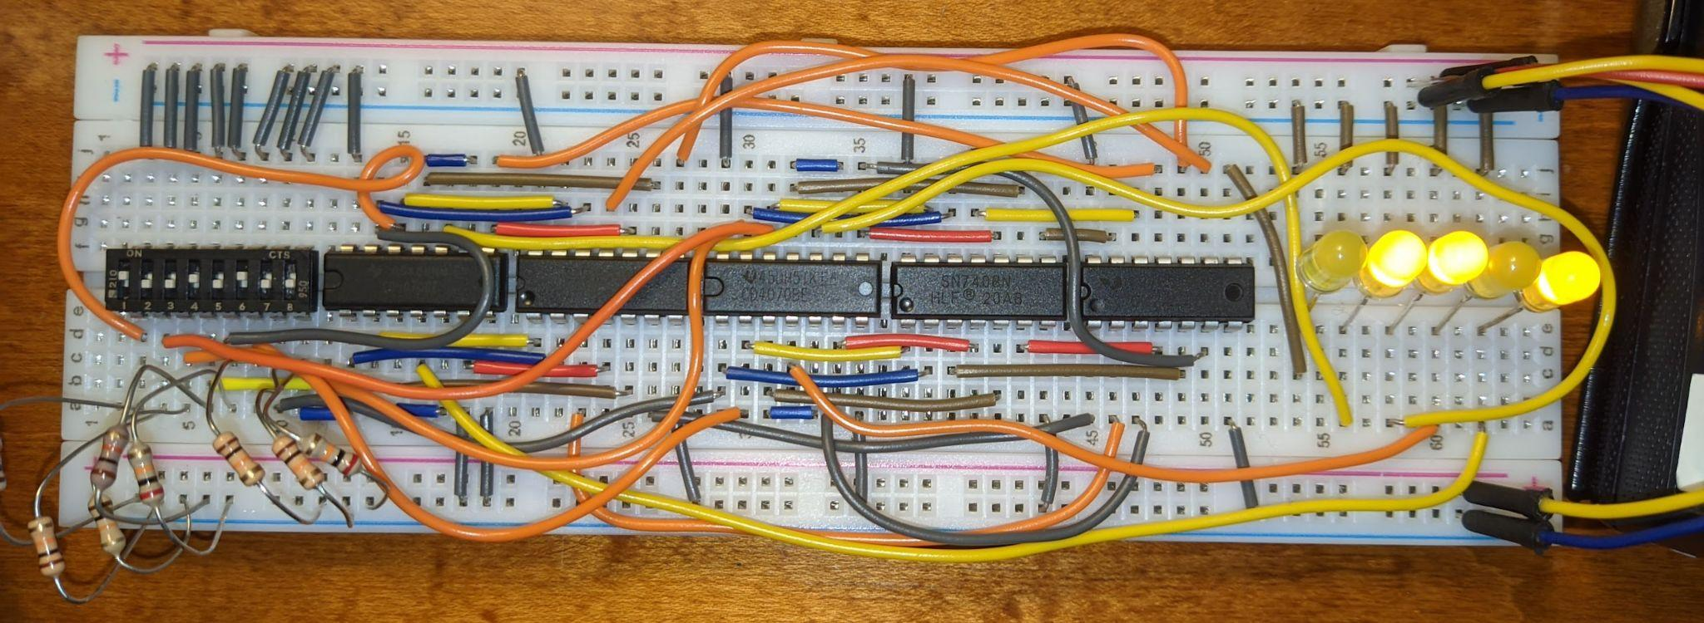

## Part 3: Modern Microcontrollers

**Goal:** Demonstrate how today’s microcontrollers utilize these computing concepts for a variety of practical purposes through programmability and ease of use and implementation.

### Project x: Mail Detector

**Project Goal**: Utilize an ESP32 microcontroller with light/motion sensor to detect when mailbox is opened. The project will be solar-powered and transmit data to Node.js server running from a raspberry pi.

Parts / Logistics:

* Esp32 microcontroller
* Solar panel
* Charging regulator
* Voltage regulator
* LiPo Battery
* Charging circuit design
* Raspberry Pi
* Arduino & Nodejs code
* Light/motion sensor (PCB???)

